NVC Help
NVC 2.2.0 -- en
Contents
Open this document in Word to build the table of contents.

Introduction
NVC is a Windows video conversion utility built around FFmpeg. It can watch a source folder, convert supported media into your chosen output format, inspect media metadata, keep logs, generate PC support reports, and optionally clean up original files after conversion.
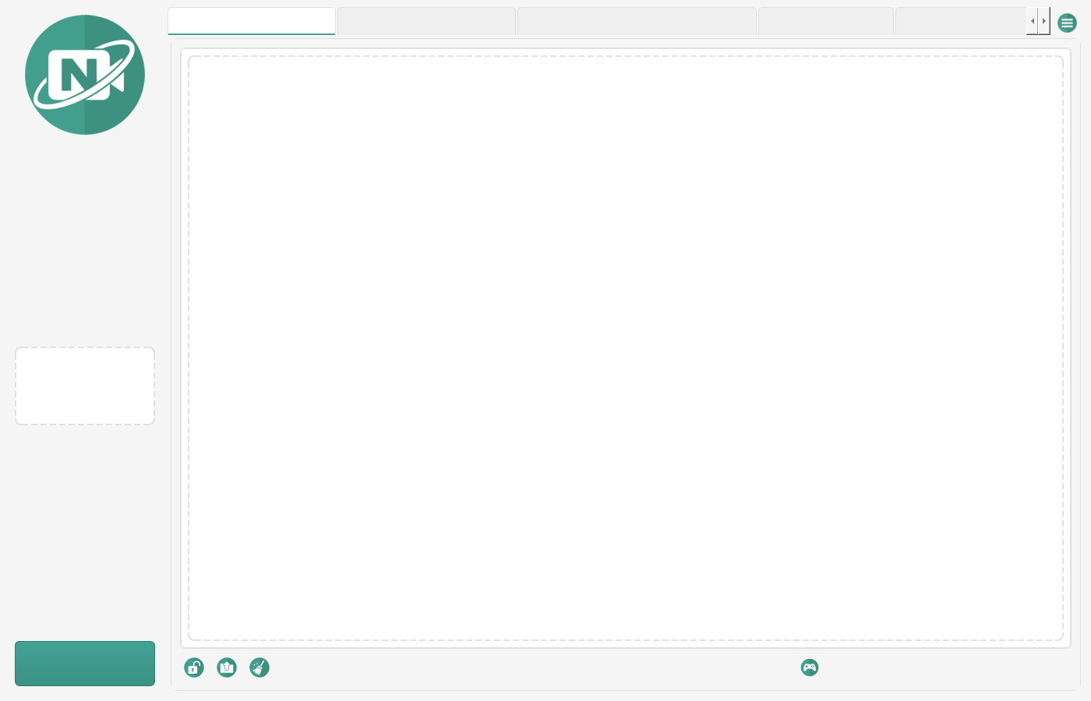
Figure 0. The NVC main window, with the conversion log and preview panel.
Note
- Overwrite policy: NVC never overwrites an already converted video. If the destination already contains video.mp4, the next output becomes video (1).mp4, then video (2).mp4 -- the same style web browsers use for duplicate downloads.

Quick Start
Six steps from a fresh install to a converted file.
- Open Settings from the menu.
- Choose a Source Folder. This is where new videos will be watched or scanned.
- Choose a Destination Folder. Converted videos are written here.
- Select the desired output format, codec, bitrate, size, and optional GIF settings.
- Click Start to begin monitoring the source folder.
- Add or drop supported videos into the source folder. NVC queues and converts them automatically.
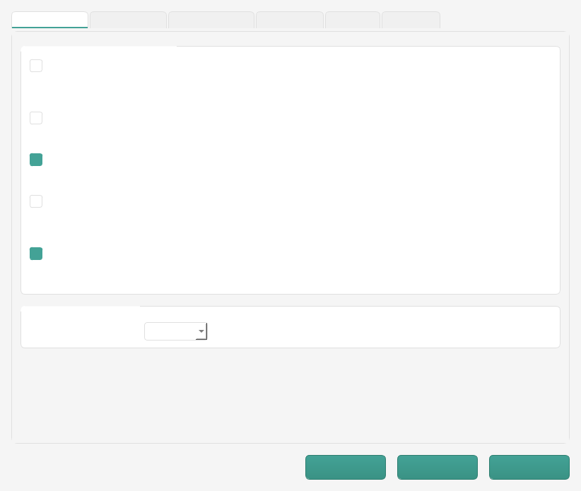
Figure 1. Settings, General tab: source and destination folders.

Main Window Overview
The main window is organised into tabs, with a shared preview panel and a status footer.
Area | What it does
Conversion Log | Shows FFmpeg output, progress messages, warnings, and completion results.
Converted Files | Tracks queued, processing, successful, and failed conversions, and links converted-file logs.
Inspection | Drag a media file here to view the FFprobe summary and raw JSON metadata.
PC Report | Generates a detailed system report covering software, drivers, devices, codecs, networking, and NVC-related components.
Lossless Editor | Trim, remux, merge, extract audio, or remove audio using FFmpeg stream-copy operations that avoid re-encoding where the source and container allow it.
Multi-Source Recorder | Records up to four FFmpeg sources, including RTSP and HTTP streams or Windows DirectShow inputs such as video=Camera Name.
Preview Panel | Shows a thumbnail or video preview when a file is selected or dropped.
Menu | Access to settings, help, info, PC reports, and extra tools.

Converting Files
When monitoring is active, NVC watches the source folder for new supported videos. Existing files in the source folder are scanned when monitoring starts. Files can also be dragged directly into the app.
NVC protects existing converted files. If a converted output name already exists, NVC chooses the next available browser-style filename:
Session.mp4
Session (1).mp4
Session (2).mp4

NVC accepts common video formats including MP4, AVI, WMV, MKV, FLV, WebM, MOV, MPEG, MPG, M4V, 3GP, TS, VOB, RM, RMVB, ASF, M2TS, MTS, OGV, DIVX, DV and F4V.
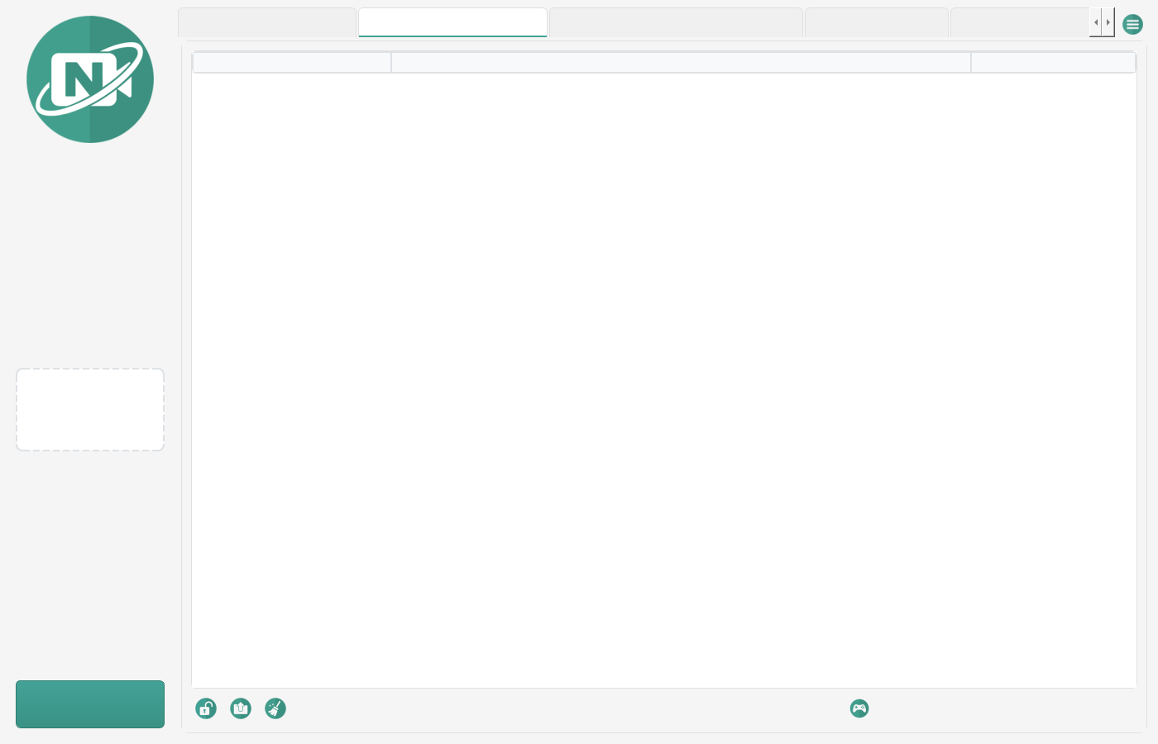
Figure 3. The Converted Files tab tracking queued and finished jobs.

Conversion Settings
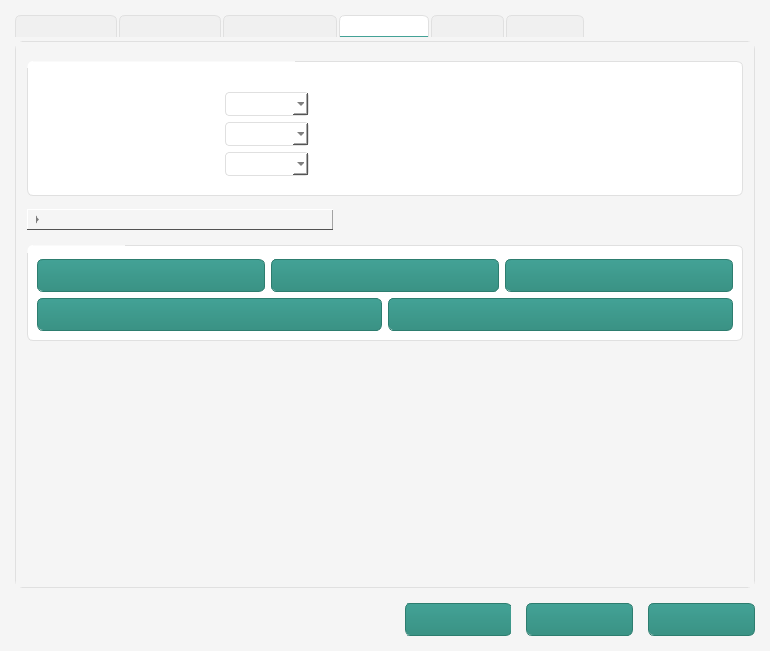
Figure 2. Settings, Format tab: output format, codec and bitrate.
Setting | Guidance
Output Format | The container to write, such as MP4 or GIF. MP4 is usually the safest general-purpose choice.
Video Codec | libx264 is widely compatible. HEVC/H.265 can create smaller files but may not play everywhere. NVC maps HEVC to the correct FFmpeg encoder.
Audio Codec | AAC is the most compatible default for MP4 output.
Video Bitrate | Use Auto unless you need a specific file size or quality target. Higher bitrate means larger files and usually better quality.
Video Size | Use Auto to preserve the original size. Choose a smaller size to reduce file size.
Frame Rate | Use Auto to preserve the source frame rate. Set this only when you need a specific playback rate.
Keyframe Interval | Advanced. Useful for streaming, scrubbing, or compatibility workflows. Leave at 0 unless you know the GOP interval you need.
Copy Only | Remuxes streams without re-encoding. Fast, but it can fail if the selected container does not support the source streams.
Custom FFmpeg Flags | Advanced users can append FFmpeg arguments. Use carefully, because invalid flags can break conversion.

GPU Encoding
If enabled, NVC attempts to use a supported GPU encoder for NVIDIA, AMD or Intel hardware. GPU encoding can be much faster than CPU encoding, but the available codecs depend on your installed GPU drivers and FFmpeg build.
H.264 GPU encoders: h264_nvenc h264_amf h264_qsv
HEVC GPU encoders: hevc_nvenc hevc_amf hevc_qsv

Note
- If the selected GPU encoder is unavailable, NVC falls back to CPU encoding where possible.
- Detection runs once per session and is cached. If you install new GPU drivers, restart NVC so it re-detects the available encoders.

GIF Export
GIF output can use a two-pass palette workflow for better colour quality. You can adjust frame rate, maximum width, looping, and quick mode. A lower frame rate and a smaller width both reduce file size.
Note
- GIF files grow quickly. For long clips, convert to MP4 instead.

Text Overlays
NVC can add overlays such as elapsed time, recorded time, recorded date and time, remaining time, or CRTV-style recording labels. Overlays require video filtering, so they may reduce GPU compatibility and conversion speed.

Original File Handling
Option | Behaviour
Keep Originals | The original file remains in place after conversion.
Delete After Conversion | NVC deletes the original immediately, or schedules deletion after the retention period.
Retention Days | 0 to 30 days. NVC stores pending deletions on disk, so overdue files are processed after a restart.
Backup Folder | Moves originals to a backup folder instead of deleting them.

Note
- Keep originals until you have confirmed the converted files play correctly.

Media Inspection
The Inspection tab uses FFprobe to show a readable summary and the detailed JSON metadata. The summary includes duration, file size, bitrate, streams, codecs, dimensions, frame rate, audio details, and keyframe estimates.
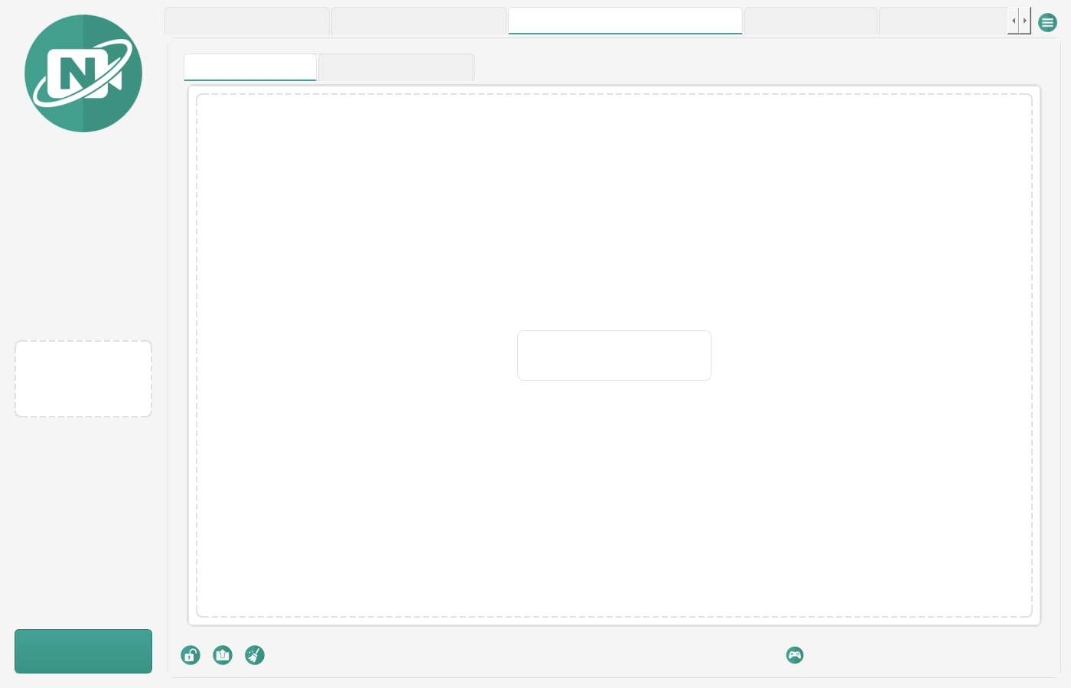
Figure 4. The Inspection tab showing an FFprobe summary.

PC Report Tool
The PC Report tool gathers system information to help with support and troubleshooting. It covers the operating system, updates, installed programs, security status, hardware, network, services, processes, environment details, printers, drivers, codecs, and NVC-specific information.
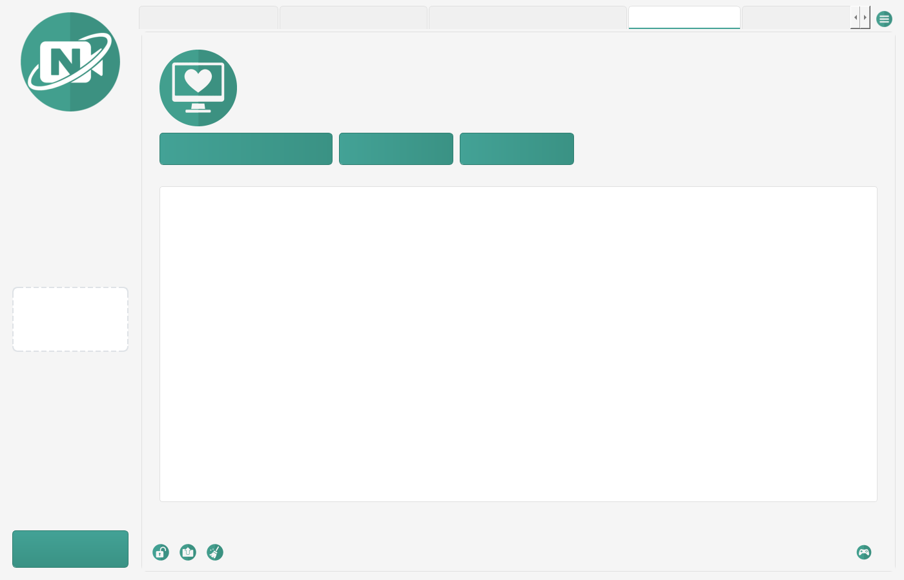
Figure 5. The PC Report tab after generating a report.
Note
- Privacy: PC reports can include sensitive machine details. With redaction enabled, NVC masks common sensitive values such as licence keys, serial numbers, MAC addresses and user profile paths. Review any report before sharing it outside your organisation.
- Some Windows collectors -- drivers, devices, network connections and processes -- can take a while on large systems.

Lossless Editor
The Lossless Editor tab provides FFmpeg stream-copy tools. These operations are fast because they avoid re-encoding wherever possible.
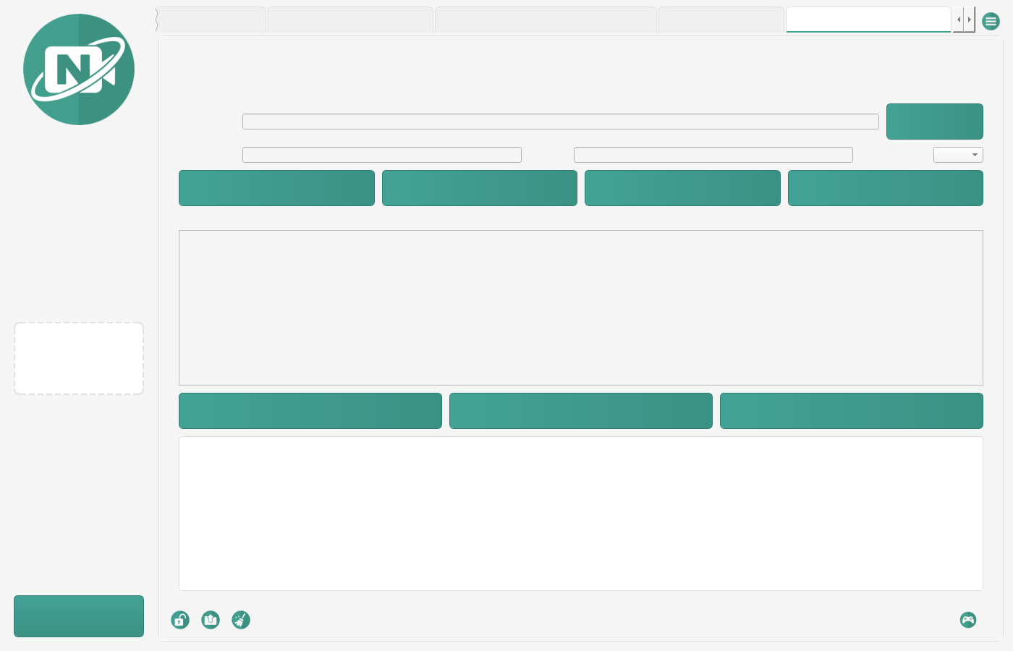
Figure 6. The Lossless Editor tab with a trim range set.
Operation | What it does
Trim Losslessly | Cuts a section between start and end timestamps using stream copy.
Remux | Rewraps media into another container such as MP4, MKV, MOV or AVI.
Extract Audio | Writes the first audio stream to an audio-only file.
Remove Audio | Writes a silent, video-only copy.
Merge Losslessly | Joins compatible clips using the FFmpeg concat demuxer.

Note
- Lossless operations need compatible codecs and containers. If FFmpeg fails, the source streams may need re-encoding, or a different output container.
- A lossless trim can only cut on a keyframe, so the actual start may shift slightly earlier than the timestamp you enter.

Multi-Source Recorder
The Multi-Source Recorder tab is a lightweight recorder for up to four FFmpeg inputs. Enter one source per row and enable the rows you want to record.
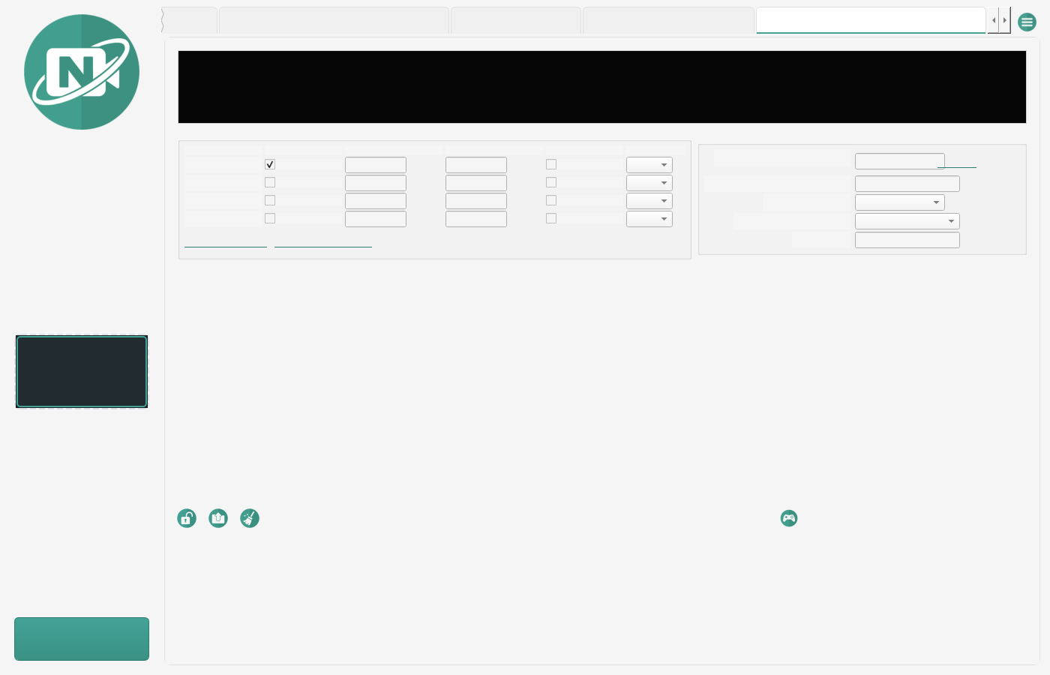
Figure 7. The Multi-Source Recorder tab with two sources enabled.
- Use RTSP, HTTP or file URLs directly, for example rtsp://192.168.1.10/stream.
- Use Windows DirectShow input strings for local capture devices, for example video=Camera Name.
- Choose copy mode for compatible streams, or h264 mode when the source needs encoding.
- Leave duration blank to record until you press Stop.

Troubleshooting
Problem | What to try
Missing FFmpeg or FFprobe | Make sure ffmpeg.exe and ffprobe.exe are present alongside the app files.
Conversion fails immediately | Check the conversion log. Invalid codec and container combinations, and custom FFmpeg flags, are the common causes.
Output file already exists | NVC creates a numbered filename automatically. Check the destination folder for (1), (2), and so on.
GPU option does not work | Update your GPU drivers, confirm FFmpeg supports your encoder, or disable GPU encoding to fall back to the CPU.
App appears idle after dropping a file | Confirm the app is unlocked, monitoring is started, and the file extension is supported.
PC report is slow | Some Windows collectors take time on large systems. Let it finish.
Something failed with no message | Set the NVC_LOG_LEVEL environment variable to DEBUG and reproduce the problem. NVC then records the full traceback for errors it would otherwise handle quietly.

NVC stores logs in its configured log folder, under the application data location unless the app configuration changes it.

Best Practices
- Use a dedicated source folder and destination folder.
- Keep originals until you have confirmed the converted files play correctly.
- Use MP4 with H.264 and AAC for the broadest compatibility.
- Use HEVC only when smaller files matter and the target players support it.
- Review PC reports before sharing them.
- Keep custom FFmpeg flags simple, and test them on a small file first.

Frequently Asked Questions
Question | Answer
Will NVC overwrite my converted videos? | No. NVC creates a numbered filename when an output already exists.
Can I convert files while monitoring is stopped? | Dropped files may be queued and processed when monitoring starts, depending on where they are dropped. Files can also be force-converted through the drag-and-drop paths meant for manual conversion.
Why did my HEVC file fail to play somewhere? | HEVC is efficient but less universally supported than H.264. If compatibility matters, use H.264.
Where are logs stored? | In the configured log folder, typically under the application data location.
Can I run two copies of NVC at once? | No. NVC allows a single instance, so two copies cannot process the same source folder.

Glossary
Terms used throughout this guide. FFmpeg terminology is kept where it is what you will see in the conversion log.
Term | Meaning
Container | The file wrapper that holds video and audio streams, such as MP4, MKV or AVI. The container is what the file extension names; it is separate from the codec used inside it.
Codec | The scheme used to compress a stream. H.264 (libx264) and HEVC (libx265) are video codecs; AAC and MP3 are audio codecs.
FFmpeg | The command-line media tool NVC runs to do the actual conversion. Its output is what appears in the conversion log.
FFprobe | FFmpeg's inspection tool. NVC uses it to read duration, streams, codecs and other metadata without converting anything.
Stream copy | Rewriting media into a new container without re-encoding it. Fast and lossless, but only possible when the target container supports the existing streams. Also called remuxing.
Remux | Changing a file's container while keeping its streams untouched. See stream copy.
Transcode | Decoding and re-encoding a stream, which changes quality and takes significantly longer than a stream copy.
Keyframe | A frame stored in full rather than as a difference from its neighbours. Seeking and lossless trimming can only land cleanly on a keyframe.
GOP | Group of Pictures: the interval between keyframes. A shorter GOP makes scrubbing more precise at the cost of file size.
Bitrate | Data used per second of media, usually in kbps or Mbps. Higher bitrate generally means better quality and a larger file.
GPU encoding | Using dedicated video hardware (NVENC on NVIDIA, AMF on AMD, Quick Sync on Intel) to encode instead of the CPU. Much faster, with codec support depending on your drivers.
DirectShow | The Windows capture interface NVC uses to record from local devices. Sources are written as video=Device Name.
RTSP | A streaming protocol used by most IP and network cameras. Sources are written as a URL, such as rtsp://192.168.1.10/stream.
Retention period | How long NVC keeps an original file after a successful conversion before deleting it. Pending deletions survive a restart.
Redaction | Masking sensitive values such as licence keys, serial numbers, MAC addresses and user paths in a PC report before it is shared.

